RAS Application Suite: Phase 4 Summary
Brian Chiasson and Dan Buhrman
This document provides a summary of the development activities for Phase 4 of the RAS development process. The document also outlines any changes to the previous project documentation as well as any new challenges that have arisen.

Milestones
The goal for Phase 4, as outlined by the Project Plan document, is to complete the membership features of the application and complete the recall search form. Development has gotten back on track a little, but we are still behind the original plan. As a result, the feature delivery for Phase 5 is significantly reduced. The plan outlined the following tasks for completion:
- Complete script to process the member registrations.
- Complete script to process the member activations.
- Configure an SMTP server for sending emails for registration (and in the future, notifications).
- Complete the script for member login.
- Complete the recall search form.

Item 1 Status – Member registration script
The membership registration form has been completed in Phase 4. The script is handling input validation (sever-side and client-side), activation token generation, and inserting the records into the database.
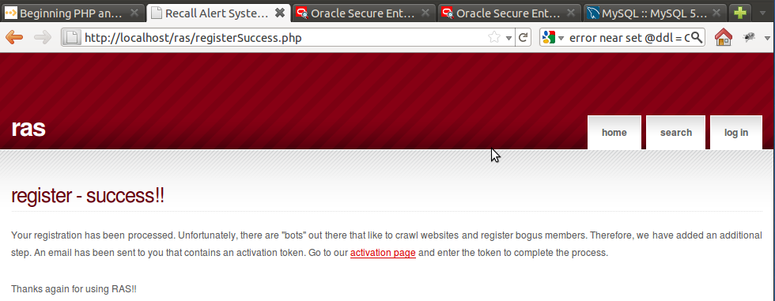
Figure 1-1: Screen of the final page in the registration process complete.

Item 2 Status – Complete script to process member activations
The task here was to create the controller script for processing the membership activation form input. This task has been completed in this phase. The members can now complete the activation. We did change the requirements of the form page to have the user submit their email address in conjunction with the activation token.
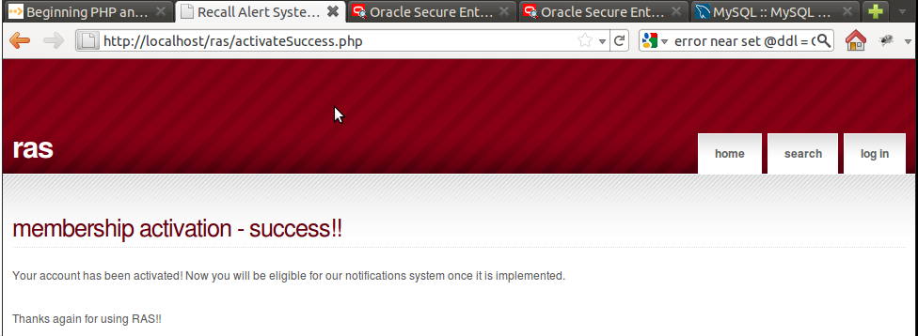
Figure 1-2: Screen shot of final page in membership activation.
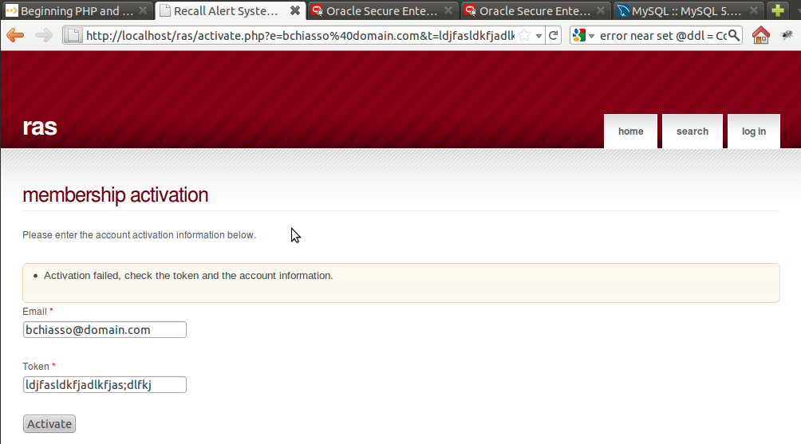
Figure 1-3: Screen shot of error when email/token is not in system database.

Item 3 Status – Configure SMTP server
The SMTP server has been installed and configured according to documentation but is still not sending out emails. The team is confident that the email server in production is functioning and the service has been built so this functionality will be tested when the site is placed online, but not made active.

Item 4 Status – Complete member login script
The member login script is complete. The feature is logging the date and time that the user logs in. If the authentication fails, the user is presented with a message that just says we cannot authenticate the user.
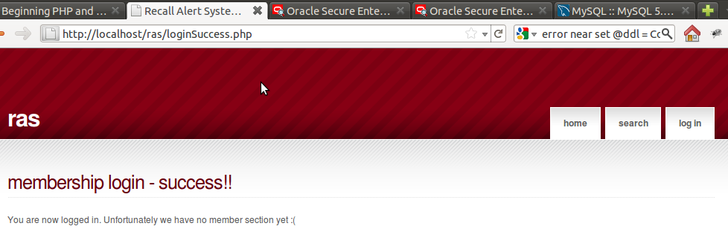
Figure 1-4: Screen shot of successful member logon.
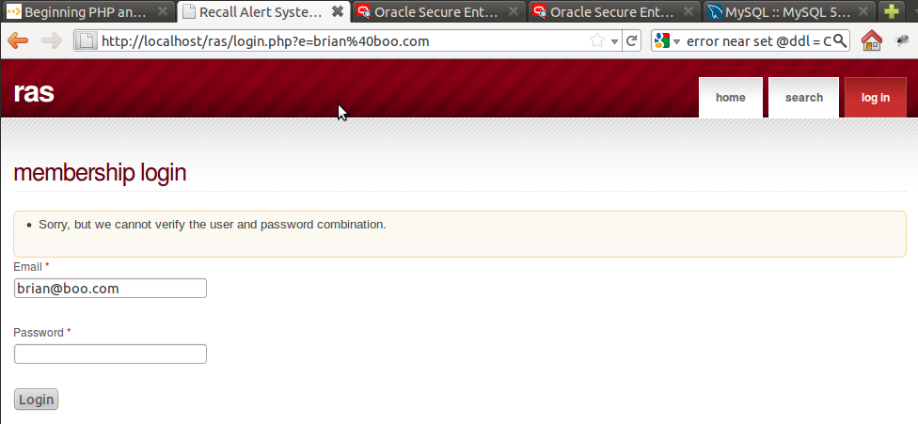
Figure 1-5: Message displayed when system can't authenticate user

Item 5 Status – Complete Recall Search form
The search form now searches for automobiles by make, model, year, or a combination of the three. If there are any recalls based on the information entered, they are displayed with a description, manufacturer, the date of the recall, and a source URL (if available).
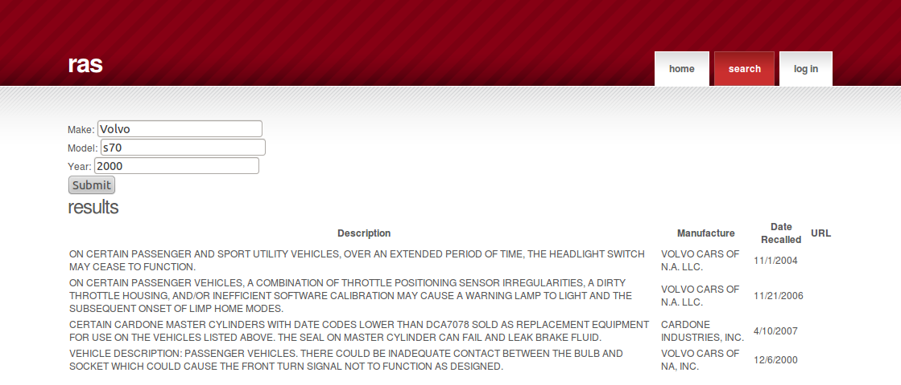Figure 1-6: Search Form with Results

Document Changes/Schedule Changes
We have adjusted the Project Plan's deliverables to reflect the move of the membership scripting to Phase 4. The updated chart is displayed below. It should be noted that pushing the scripting to Phase 4 has impacted Phase 5 and makes it official that the development team will not be able to get to the notifications system.

Deliverable | Date
Project Plan | 6/19
Meeting Notes | 6/20
System & Software Specification | 6/26
Meeting Notes | 6/27
Test Plan & User Guide | 7/3
Meeting Notes | 7/4
Design | 7/10
Meeting Notes | 7/11
Hosted Website (Phase 1)  Provide a hosted webpage with the ability to search for automotive recall data. | 7/17
Meeting Notes | 7/18
Membership Feature (Phase 2)  Complete website template. Enhance the website by adding a membership feature. | 7/24
Meeting Notes | 7/25
Food Recalls (Phase 3)  Complete membership control scripting. Configure SMTP server. Enhance the website by adding the ability to search for food recall data. | 7/31
Meeting Notes | 8/1
Consumer Goods Recalls (Phase 4)  - Finish member registration  - Complete SMTP server setup  - Complete membership activation  - Complete membership login  - Complete the recall search form  - Enhance the website by adding the ability to search for consumer goods recall data. | 8/7
Meeting Notes | 8/8
Touch-ups (Phase 5)  Include any bug fixes, touch-ups, and any other enhancements agreed upon. | 8/14
Meeting Notes | 8/15
Final Report | 8/21
Table 1-1: Updated Project Deliverables

Retrospective
There are quite a few bows left to tie on some of the features developed. Little things like unique constraints to ensure that users don't register multiple times, and the login page should probably redirect the user back to the referring that made them log in. These items will be addressed in Phase 5 and any unresolved items will be outlined in the final project documentation.

